Sentinel Healthcare:
A Delegate’s Guide to Zoom Meetings

To facilitate online education and training, Sentinel Healthcare is making use of several online platforms to bring people together virtually.

A successful system for our online discussions is Zoom, which is widely used by companies and individuals around the world.

Below is a short guide to using Zoom when joining our meetings and forums.

Before you start
If you already use Zoom, it is worth checking that you are using the most up to date version of the program. Please only download software updates from a trusted source, such as the official website.
This guide is designed for meeting attendees that are using a laptop, tablet or computer that is connected to the internet, and has a webcam and microphone. If you are planning to join the meeting by telephone please contact us: SHS.SentinelDiabetes@nhs.net

- You will receive an invitation.
We are asking people to register for online meetings arranged by Sentinel Healthcare. You will receive an email from us inviting you to attend the Zoom meeting. In the email, there will be a section that looks like this:

Hi there,

You are invited to a Zoom meeting.
When: May 10, 2020 01:00 PM London

Register in advance for this meeting:
https://us02web.zoom.us/meeting/register/tZ0lce6orjgpGdeByZft8jP29gXKBIMgVz5g

After registering, you will receive a confirmation email containing information about joining the meeting.

When you get the email, click on the link to be taken to your registration page. If you already have a Zoom account, you can use your own details. If you are new to Zoom or don’t want to use a personal account, you can quickly register your preferred email account on the site for free. Please ensure that you have a strong password that is known only to you. Once you have registered, you will be sent the link to be able to attend the meeting.

If you are given Meeting ID or Password information, please keep these details secure.

If you do not already have a Zoom account, you can create one here:

The details of your event will be shown here:

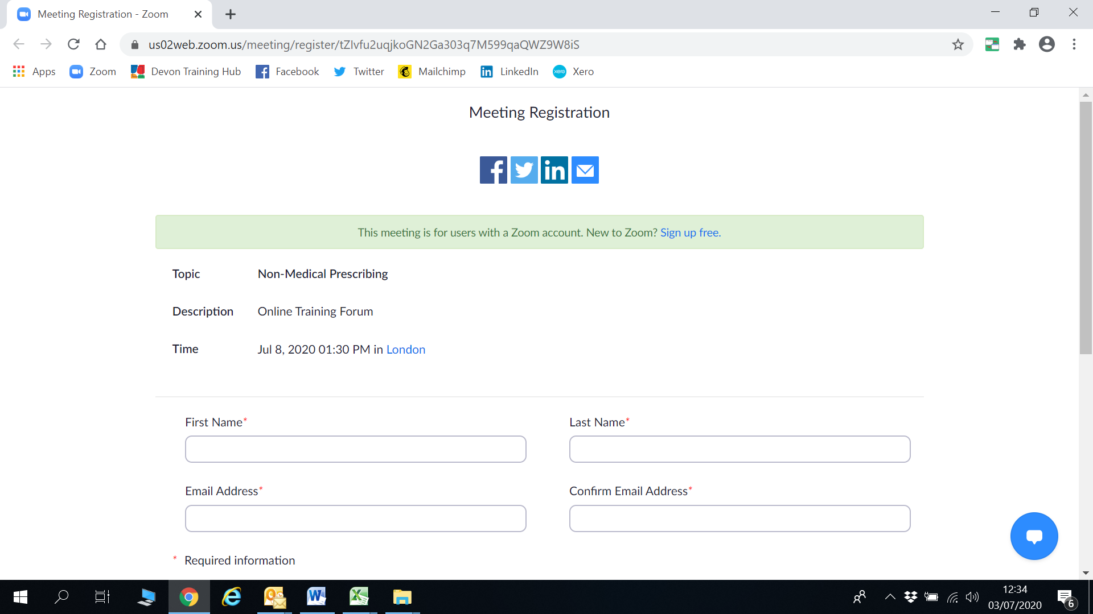

If you have just created an account, make sure that you come back to this page to also register for the meeting.

If you already have an account, you can quickly register for the meeting on this page, and a confirmation email will be with you in the next few minutes. This has been generated by Zoom but will appear to have been sent by Sentinel Healthcare. If the email is not received in your inbox, please also check your junk or spam folders.

- Open Zoom

When you have clicked on the link to attend the meeting, your computer will open Zoom in a new tab on your internet browser.
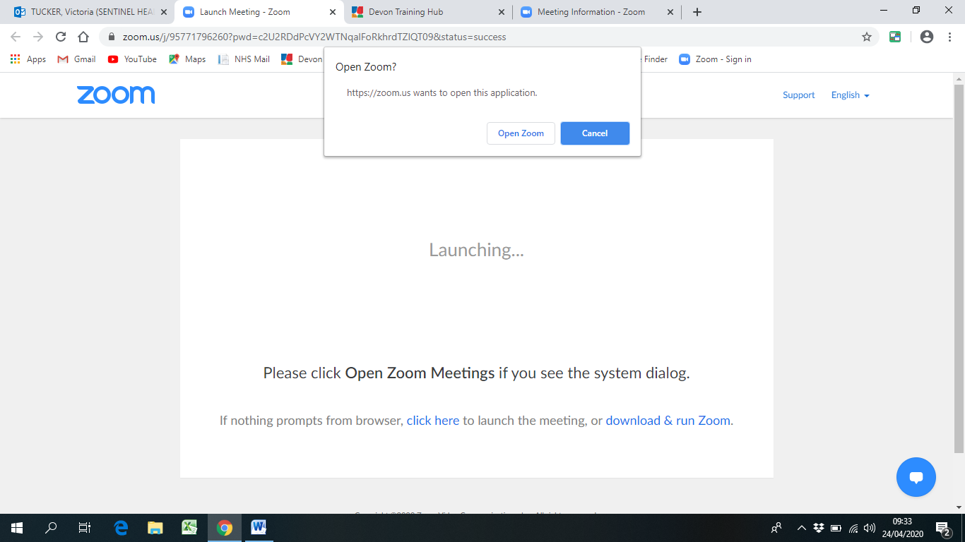

Click ‘Open Zoom’ to get the program started.

You will see this if the host hasn’t yet started the meeting:

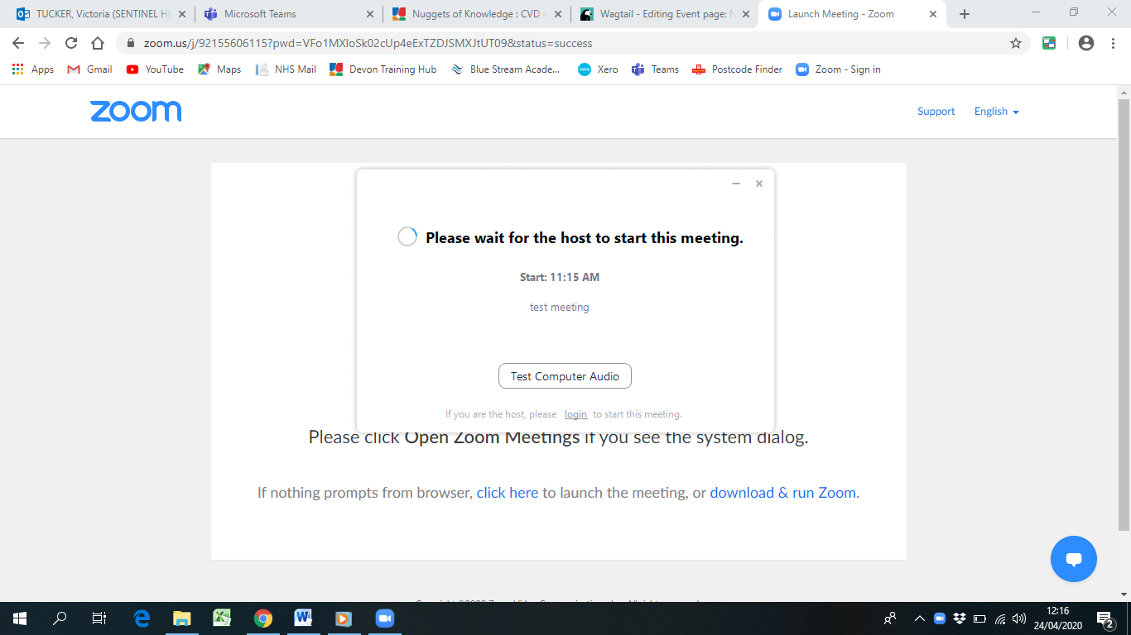

When the host has started the meeting, someone will admit you to the virtual meeting room.

This is the screen you will see while you are waiting. Your video and microphone will have been muted by Sentinel Healthcare.

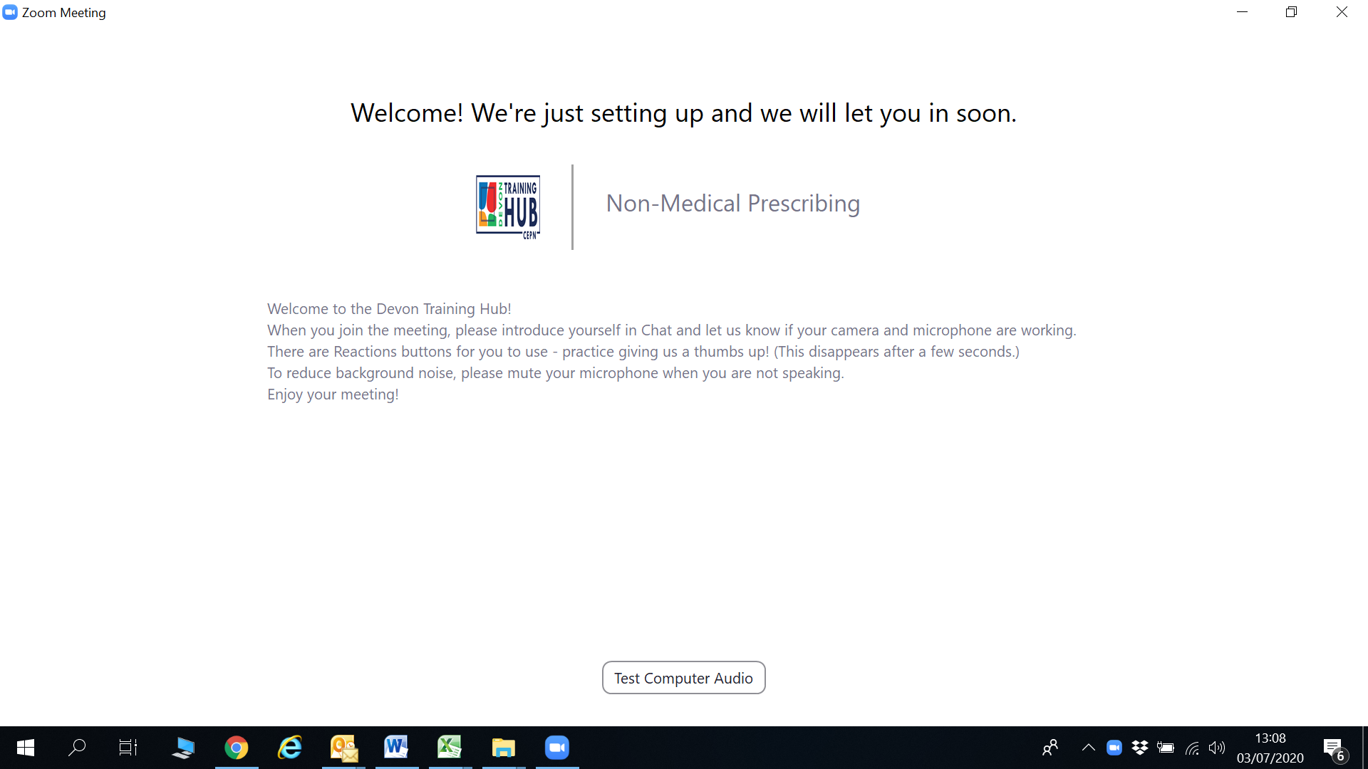

You will need to click on Join with computer audio, however Sentinel Healthcare will have muted the microphones of all attendees.
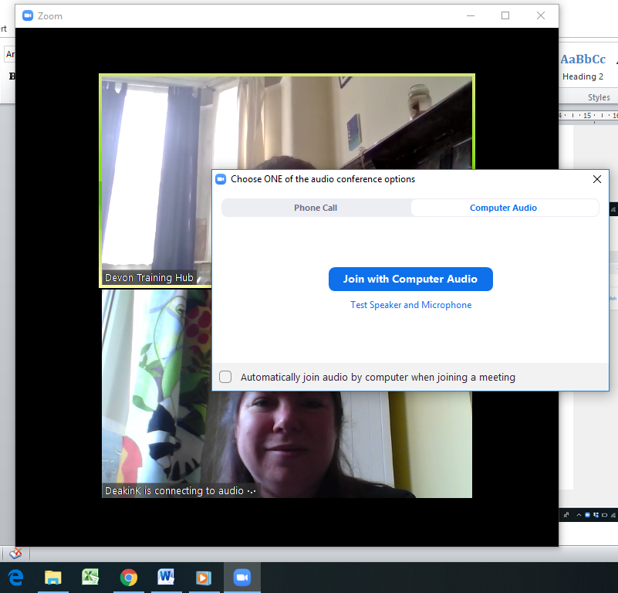

- Take part in the meeting

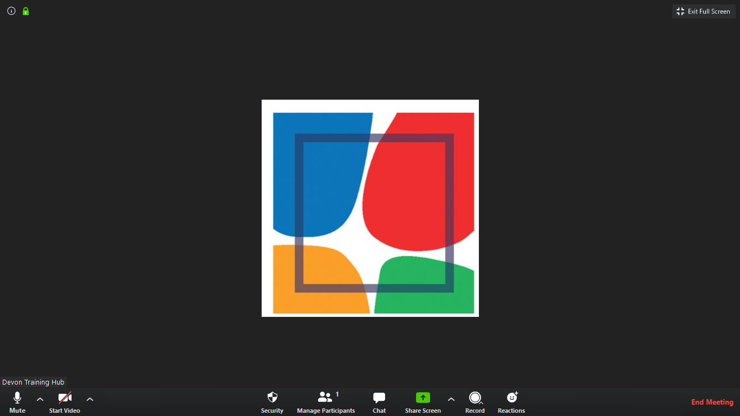

Full Screen on/off

Muted microphone

Webcam on/off
Use an emoji (clap hands or thumb up) to react to a question or poll.

Chat – write a question or comment to the educators (other attendees will not see your chat)

Your meeting might look like this….

Gallery / Speaker View

Gallery view will let you the educators, Speaker view will show you the person that is speaking in the middle of your screen. You can change this at any time.

- Finishing the meeting
At the bottom right hand corner of your screen there is a red link; Leave Meeting. Click on this to end your participation in the meeting. This will not end the meeting for other people as it will be the host that controls when the meeting starts and finishes.

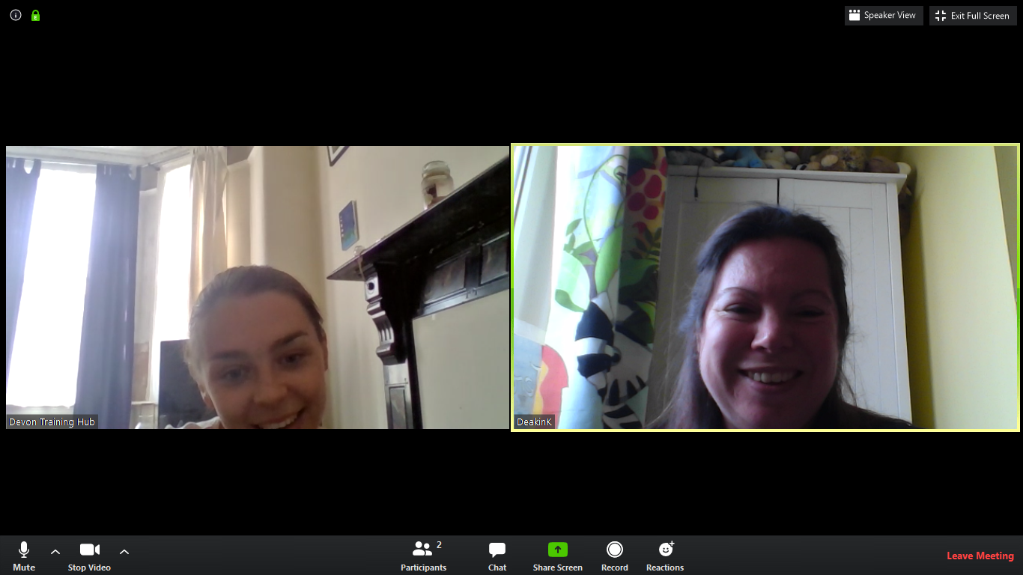
Enjoy your meeting!

